**Comprehensive Report on Wine Review Analysis**

**Introduction**

The goal of this analysis is to extract meaningful insights from a dataset of wine reviews. By applying text mining, sentiment analysis, and topic modeling techniques, we aim to understand common themes, customer sentiments, and key descriptive elements in wine reviews.

**1. Data Preprocessing and Text Mining**

Before performing any analysis, we cleaned and prepared the dataset by:

* Converting text to lowercase
* Removing punctuation and numbers
* Eliminating stopwords
* Applying stemming to reduce words to their root forms

**Corpus Cleaning and Tokenization**

A corpus was created from the wine descriptions, and stopwords were removed to ensure only meaningful words remained. Stemming was then applied to standardize words into their base forms.

**Word Frequency Analysis**

A word frequency count was conducted to identify the most common words appearing in reviews. Below is a bar chart showcasing the top 20 words:

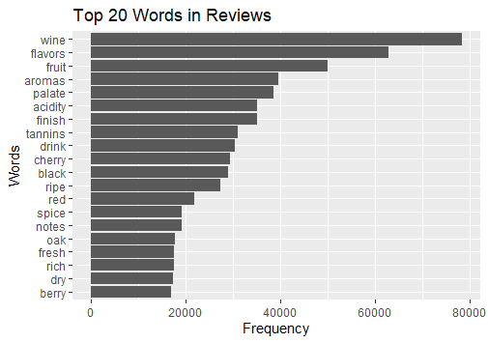

A word cloud was also generated to visualize frequently occurring terms in a more intuitive manner.

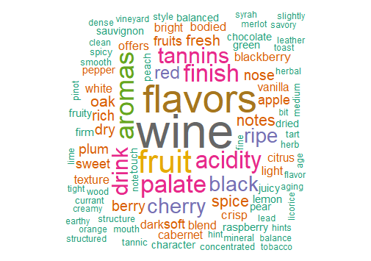

**2. Sentiment Analysis**

Sentiment analysis was performed using the Bing lexicon to classify words as either positive or negative. This helped us determine the overall sentiment distribution of wine reviews.

**Sentiment Distribution**

A sentiment distribution chart was generated to show the relative frequencies of positive and negative words in reviews.

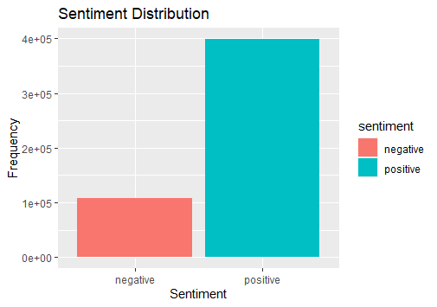

**Positive and Negative Word Clouds**

Separate word clouds were created to highlight the most common positive and negative words used in the reviews.

* **Positive Words:**

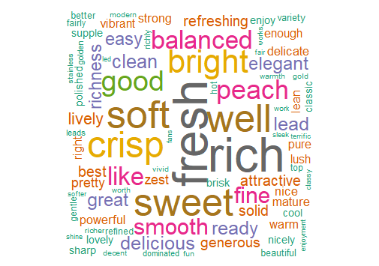

* **Negative Words:**

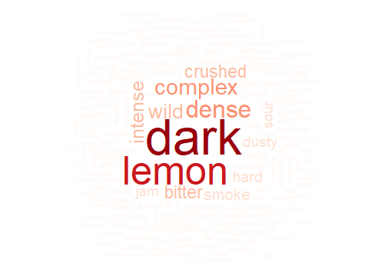

**3. Topic Modeling**

Latent Dirichlet Allocation (LDA) was used to extract major topics from the dataset. The top 10 terms for each topic were identified, revealing key themes discussed in the reviews.

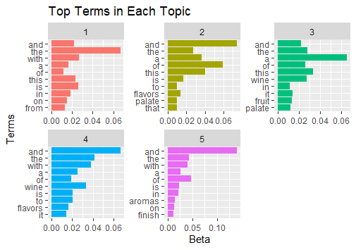

**4. Advanced Text Analysis**

**TF-IDF Analysis**

Term Frequency-Inverse Document Frequency (TF-IDF) was computed to identify the most unique and important words in the dataset.

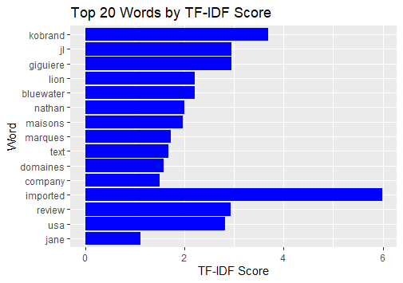

**Bigram Analysis**

A bigram analysis was performed to uncover commonly occurring word pairs in reviews, helping to identify descriptive phrases often used by customers.

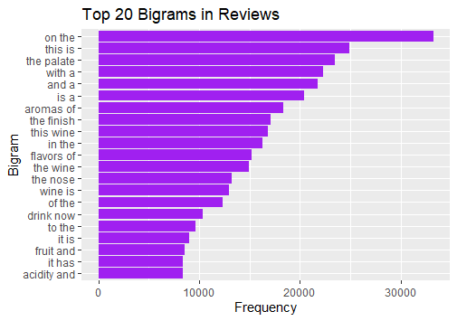

**Conclusion and Insights**

This analysis has provided valuable insights into wine reviews, including:

* Common words and themes in customer descriptions
* Sentiment distribution and factors influencing review sentiment
* Regional differences in wine sentiment
* Key topics discussed in wine reviews

These insights can be used to improve marketing strategies, enhance product descriptions, and understand customer preferences better.